# Classification Status of Hydropower In Nepal.

Hydroelectric energy, also called hydroelectric power or hydroelectricity, is a form of energy that harnesses the power of water in motion—such as water flowing over a waterfall—to generate electricity.

Power generation using hydro resources offers sustainable, zero energy input cost, zero greenhouse gas emission, low operating and maintenance cost alternative to fossil fuel based power generation. Currently, nearly 17% of the world’s total power generation is based on hydro resources and its share to renewable power generation is 70%. Although hydropower is produced in 150 countries, Nepal’s economically feasible hydropower generation capacity is one of the highest. However, this huge hydropower potential is still untapped. By harnessing the hydro resources Nepal can meet its domestic demand, create a surplus for export and generate employment for its citizens.

# Classification:

## Classification on basis of plant capacity:

As per the Department of Energy the hydropower plant based capacity is classified into 3 categories:

1. Large Hydropower Plant that generates power over 10 MW,
2. Small Hydropower Plant which generates between 1 and 10 MW
3. Micro Hydropower Plant that produces less than 1 MW.
4. Pico hydropower plant that produce less than 5 KW

## CLASSIFICATION OF HYDROPOWER - IN TERMS OF Available Head

1. Ultra Low Head :- Below 3 meters
2. Low Head :- Above 3 m and up to 40 m
3. High head :- Above 40m

## Classification in terms of water usage:

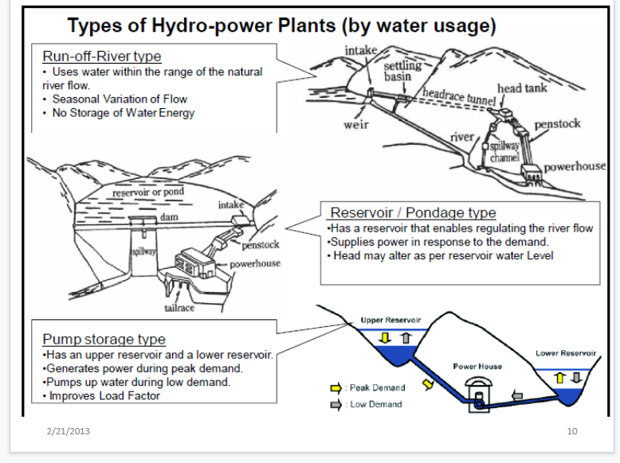

# Status of Hydro Power Plants:

With approximately 1 GW of installed capacity, hydropower provides almost all of Nepal’s domestic electricity generation on the grid. The economy is experiencing rising power demand, with forecasts that it will more than double by 2025 compared to 2018, making clear the need for new capacity.

According to its annual report, the public-owned Nepal Electricity Authority (NEA) owns 50 per cent of the country’s hydropower assets and the other 50 per cent is owned by independent power producers (IPPs). Additions in 2018 included the 30 MW Chameliya hydropower plant. The run-of-river project was inaugurated by the former Prime Minister of Nepal, Sher Bahadur Deuba, in February 2018, marking the end of a 10-year long development period.

Recently commissioned IPPs include the 13.6 MW Thapa Khola hydropower plant, commissioned at the end of 2017, and the 13 MW Madkyu Khola project which came online in 2018, alongside smaller plants. The new Dhalkebar-Muzaffarpur transmission line from Nepal to India was also commissioned in 2018, giving a welcome boost to Nepal’s power system.

These steps are part of the government’s ambitious plans to reach 5 GW total hydropower capacity over the next five years, as recently set out in a white paper by the Ministry of Energy, Water Resources and Irrigation. Nepal is also looking to improve the governance of its electricity sector, including establishing a new Electricity Regulatory Commission (ERC) which would help increase private sector investment.

There are several ongoing hydropower developments due to come online in the next couple of years. Construction of the 456 MW Upper Tamakoshi project near the border with Tibet is just completed. The run-of-river plant will be the country’s largest hydropower station expanding national capacity significantly and has been fully funded by domestic sources including the NEA and other local organisations. The first unit aims to start production at the end of 2019. The 60 MW Upper Trishuli 3A hydropower and 14 MW Kulekhani III plants are also both expected to be completed in 2019, with a series of other public and private construction projects planned.

Most of Nepal’s existing hydropower stations are run-of-river schemes, meaning power generation is impacted by seasonal rainfall patterns. With further large run-of-river projects in the pipeline, there is a need to manage surplus power produced during the monsoon months (typically from around May to October), while facing deficits in the dry seasons. To address this, the NEA is planning storage schemes including the 140 MW Tanahu project and other, larger reservoir projects. This infrastructure will play an important role in regulating the power system and managing water resources.

The Nepali government is also looking to greater regional interconnection to help balance supply and demand. As a member of the South Asian Association for Regional Cooperation (SAARC), Nepal has access to the region’s electricity markets and is looking to expand its power trading agreements with India, as well as other countries such as Bangladesh and China.

## Some hydropower power plant and their capacities are:

1. Kaligandaki Hydropower Plant, Syangja
   * Capacity: 144,000 kW
   * Project Owner: Nepal Electricity Authority

1. Middle Marsyangdi Hydropower Project, Rasuwa

* Capacity: 70,000 kW
* Project Owner: Nepal Electricity Authority

1. Marshyangdi Hydropower Plant, Tanahun

* Capacity: 69,000 kW
* Project Owner: Nepal Electricity Authority

1. Khimti Hydropower Plant, Dolakha

* Capacity: 60,000 kW
* Project Owner: Himal Power Limited

1. Kulekhani I Hydropower Plant, Makawanpur

* Capacity: 60,000 kW
* Project Owner: Nepal Electricity Authority

1. Bhotekoshi Hydropower Project, Sindhupalchok

* Capacity: 36,000 kW
* Project Owner: Bhote Koshi Power Company

1. Kulekhani II Hydropower Plant, Makawanpur

* Capacity: 32,000 kW
* Project Owner: Nepal Electricity Authority

1. Trishuli Hydropower Plant, Nuwakot

* Capacity: 24,000 kW
* Project Owner: Nepal Electricity Authority

1. Chilime Hydropower Project, Rasuwa

* Capacity: 20,000 kW
* Project Owner: Chilime Hydropower Company

1. Gandaki Hydropower Plant, Nawalparasi

* Capacity: 15,000 kW
* Project Owner: Nepal Electricity Authority

1. Devighat Hydropower Plant, Nuwakot

* Capacity: 14,000 kW
* Project Owner: Nepal Electricity Authority

1. Modi Hydropower Plant, Parbat

* Capacity: 14,000 kW
* Project Owner: Nepal Electricity Authority

1. Upper Modi Hydropower Project, Parbat

* Capacity: 14,000 kW
* Project Owner: GITEC Nepal Private Limited

1. Jhimruk Hydropower Plant, Pyuthan

* Capacity: 12,300 kW
* Project Owner: Butwal Power Company

1. Sunkoshi Hydropower Plant, Sindhupalchok

* Capacity: 10,050 kW
* Project Owner: Nepal Electricity Authority

1. Indrawati Hydropower Project, Sindhupalchok

* Capacity: 7,500 kW
* Project Owner: National Hydropower Company

1. Puwa Hydropower Plant, Ilam

* Capacity: 6,200 kW
* Project Owner: Nepal Electricity Authority

1. Andhikhola Hydropower Plant, Syangja

* Capacity: 5,100 kW
* Project Owner: Butwal Power Company

1. Chatara Hydropower Project, Sunsari

* Capacity: 3,200 kW
* Project Owner: Nepal Electricity Authority

1. Panauti Hydropower Project, Kavre

* Capacity: 2,400 kW
* Project Owner: Nepal Electricity Authority

These are some of the running hydropower power plants in Nepal